ATM Monitoring System - Activity Flow Diagrams

## **Overview**

This document outlines the activity flow for a service running on ATM devices and the monitor service. The Monitor service is responsible for authenticating transactions and logging transaction outcomes. Other bank services utilize these logs via the same.

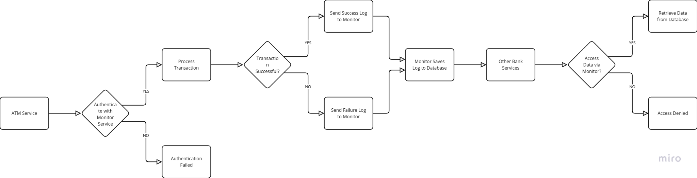

## **Activity Flow**

1. **Authentication Process**
   * The Monitor service authenticates the transaction request.
   * Authentication involves verifying the Atm Devices and other services.
2. **Transaction Outcome Logging**
   * Upon authentication, the logs are sent to the monitor service.
   * The ATM service logs the transaction outcome (success or failure).
   * These logs are sent to the monitor service.
3. **Monitor Service Logging**
   * The monitor service receives transaction logs from the ATM service.
   * Logs are saved in the database for future reference and analysis.
4. **Data Access by Bank Services**
   * Other bank services access transaction data through the monitor service.
   * Available data includes:
     + Total number of Successful transactions
     + Total number of failed transactions
     + Video downloads related to transactions
5. **Database Interaction**
   * The monitor service mediates all interactions with transaction logs and camera data.
   * Direct access to the database is not permitted for bank services, ensuring data security and integrity.

## **Conclusion**

The ATM service, in conjunction with the monitor service, provides a secure and efficient method for handling transaction logs and facilitating data access for bank services. This structured flow ensures that all transaction data is accurately logged and accessible only through authorized channels.